**TOPIC 09: USING DDL Statements**

**Exercises**

**\*\*\* This exercise is performed on HR Schema (HR database) \*\*\***

**\*\* This exercise may include some of the topics examined previously\*\***

1. Determine how many objects of each type are in your schema.

select object_type, count(object_type) from user_objects group by object_type;

1. Determine how many objects in total your schema has permissions on:

select count(*) from all_objects;

1. Determine who owns the objects your schema can see.

select distinct owner from all_objects;

1. Write query to read similar information like the ones you get when you use DESCRIBE command. Issue this command for table REGIONS.

select column_name "name", nullable "Null?", concat(concat(concat(data_type,'('),data_length),')') "type"

from user_tab_columns

where table_name='REGIONS'

1. Use a query against a data dictionary view to show what columns make up the EMPLOYEES table, as the DESCRIBE command would:

select column_name "Name", nullable "Null?", concat(concat(concat(data_type,'('),data_length),')') "Type"

from user_tab_columns

where table_name='employees';

1. Below are given relational model and ERD model. According to the presented models, generate SQL DDL statements.

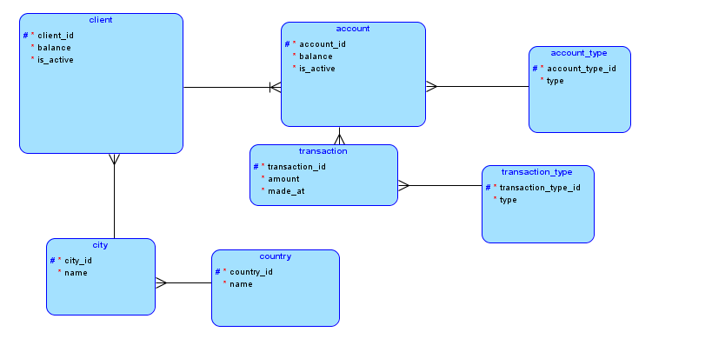

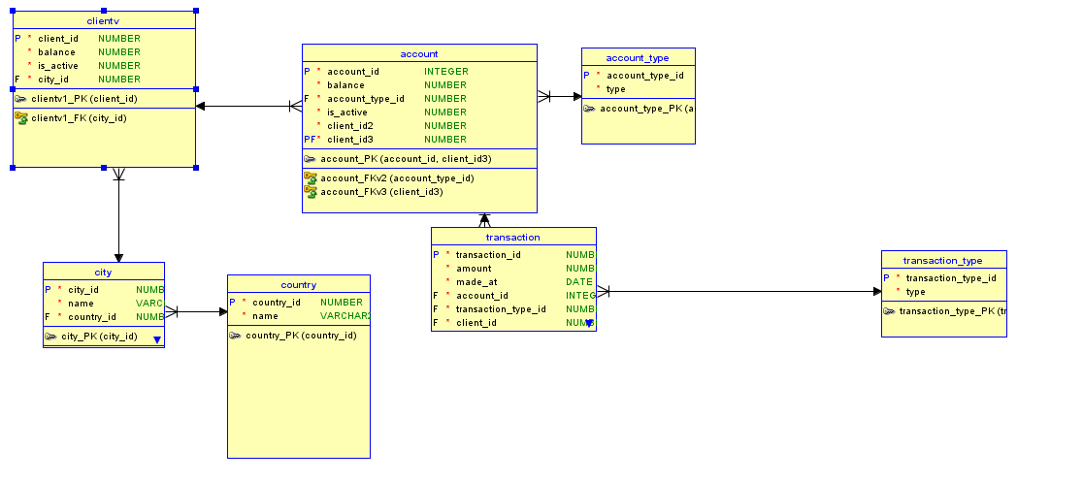

CREATE TABLE account (

account_id INTEGER NOT NULL,

balance NUMBER,

is_active NUMBER,

client_client_id NUMBER NOT NULL,

account_type_account_type_id INTEGER NOT NULL,

client_id NUMBER NOT NULL

);

ALTER TABLE account ADD CONSTRAINT account_pk PRIMARY KEY ( account_id, client_id );

CREATE TABLE account_type ( account_type_id INTEGER NOT NULL, type VARCHAR2(30));

ALTER TABLE account_type ADD CONSTRAINT account_type_pk PRIMARY KEY ( account_type_id );

CREATE TABLE city (city_id NUMBER NOT NULL,name VARCHAR2(30),country_country_id NUMBER NOT NULL);

ALTER TABLE city ADD CONSTRAINT city_pk PRIMARY KEY ( city_id );

CREATE TABLE client (

client_id NUMBER NOT NULL,

balacne NUMBER NOT NULL,

is_active NUMBER NOT NULL,

city_city_id NUMBER NOT NULL

);

ALTER TABLE client ADD CONSTRAINT client_pk PRIMARY KEY ( client_id );

CREATE TABLE country (

country_id NUMBER NOT NULL,

name VARCHAR2(30));

ALTER TABLE country ADD CONSTRAINT country_pk PRIMARY KEY ( country_id );

CREATE TABLE transaction (

transaction_id NUMBER NOT NULL,

amount NUMBER,

made_at DATE,

account_account_id INTEGER NOT NULL,

account_client_client_id NUMBER NOT NULL,

transaction_type_transaction_type_id NUMBER NOT NULL,

client_id NUMBER NOT NULL);

ALTER TABLE transaction ADD CONSTRAINT transaction_pk PRIMARY KEY ( transaction_id );

CREATE TABLE transaction_type (transaction_type_id NUMBER NOT NULL,type VARCHAR2(30));

ALTER TABLE transaction_type ADD CONSTRAINT transaction_type_pk PRIMARY KEY ( transaction_type_id );

ALTER TABLE account ADD CONSTRAINT account_account_type_fk FOREIGN KEY ( account_type_account_type_id ) REFERENCES account_type ( account_type_id );

ALTER TABLE account ADD CONSTRAINT account_client_fk FOREIGN KEY ( client_client_id ) REFERENCES client ( client_id );

ALTER TABLE city ADD CONSTRAINT city_country_fk FOREIGN KEY ( country_country_id ) REFERENCES country ( country_id );

ALTER TABLE client ADD CONSTRAINT client_city_fk FOREIGN KEY ( city_city_id ) REFERENCES city ( city_id );

ALTER TABLE transaction ADD CONSTRAINT transaction_account_fk FOREIGN KEY ( account_account_id, client_id ) REFERENCES account (account_id, client_id );

ALTER TABLE transaction ADD CONSTRAINT transaction_transaction_type_fk FOREIGN KEY ( transaction_type_transaction_type_id ) REFERENCES transaction_type ( transaction_type_id );